Rosenberger Appointed USConec Partner Supplier for MDC 3X Density Solution

Akron, PA – September 24th , 2019 – USConec, a global leader in the design and development of high-density optical interconnects and Rosenberger, a global leader in Fiber Optic solutions have announced a collaboration in the deployment of USConec’s MDC 3X density solution for Hyper Scale Data Center and other applications.

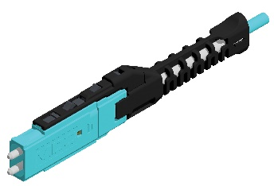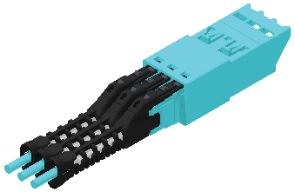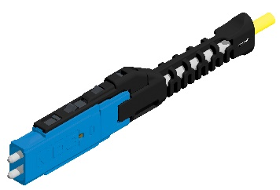

Offering 3X density of duplex LC connectors, the MDC duplex brings simple insertion/extraction using a built-in push/pull boot, and field polarity configurability. This ensures the MDC solution meets today’s challenges of high-density fiber management in the data center environment. Transferring proven 1.25mm ferrule technology from LC connectors ensures performance and reliability expected by installers.

Rosenberger is developing various cable and fiber management solutions incorporating the MDC and will display some of them at BICSI, Las Vegas for users to experience the 3X density in person. Customers are invited to see this and other innovative new solutions that Rosenberger is bringing to the USA data center and enterprise markets.

Please visit Rosenberger in Booth 947 at BICSI, Las Vegas for a demo of the MDC connector and panel solution and experience Rosenberger’s portfolio of innovative fiber and fiber management solutions.

About Rosenberger
Rosenberger is a privately-owned diversified Bavarian manufacturing company with sales of €1,300mio and over 11,000 employees globally. Rosenberger is a development and production leader in RF, Fiber Optic and Interconnect solutions, operating in the Data Center, Mobile Communication, Test + Measurement, Automotive, Medical, Industrial, Telematics and custom machining markets. Since 1991 Rosenberger is an expert in innovative fiber optic cabling infrastructure and service solutions for Data Centers, Local Networks, Telecom and Industrial markets.

Rosenberger North America is headquartered at 309 Colonial Drive, Akron, PA 17501 Telephone: +1 717 859 8900
www.rosenberger.com and is a wholly owned subsidiary of Rosenberger Hochfrequenztechnik GmbH & Co. KG, P.O.Box 1260, D-84526, Tittmoning Telephone: +49-8684-18-0 www.rosenberger.de

About USConec
USConec is a global leader in the design and development of high-density optical interconnects. With over 25 years of innovative experience, the company provides industry leading components for data center and enterprise structured cabling, public networks, on-board optical interconnects, industrial and military markets worldwide. Key product developments include single-mode and multimode MT-style and custom multi-fiber ferrules, MTP® brand MPO connectors, MXC® connectors, PRIZM® LightTurn® and PRIZM® MT lensed ferrule technology, ELiMENT™ single fiber connector solutions, IBC™ brand fiber optic cleaning solutions, termination equipment for multi-fiber interconnects, and high precision optical packaging components. US Conec is headquartered in Hickory, North Carolina, and is an equity venture of three leading communication technology companies—Corning Optical Communications, Fujikura, and NTT-AT

