September 23rd 2019, Akron, PA

Rosenberger introduces FTH-9 Plus Wave ODF Cabinet for Seismic Zone 4 “Ring of Fire” Sensitive Installations

Akron, PA: Rosenberger launches and demonstrates at BICSI, Las Vegas its newly designed Zone 4 “Ring of Fire” seismic sensitive optimized Optical Distribution Fiber (ODF) Cabinet. The ‘FTH-9 Plus Wave’ Optical Fiber Management Solution has been designed to meet the increased requirements of IEEE 693-2005, “IEEE Recommended Practice for Seismic Design of Substations” and engineered to meet the latest fiber management standards in data centers. The FTH-9 solution offers Data Center designers and installers confidence they are preparing for all eventualities.
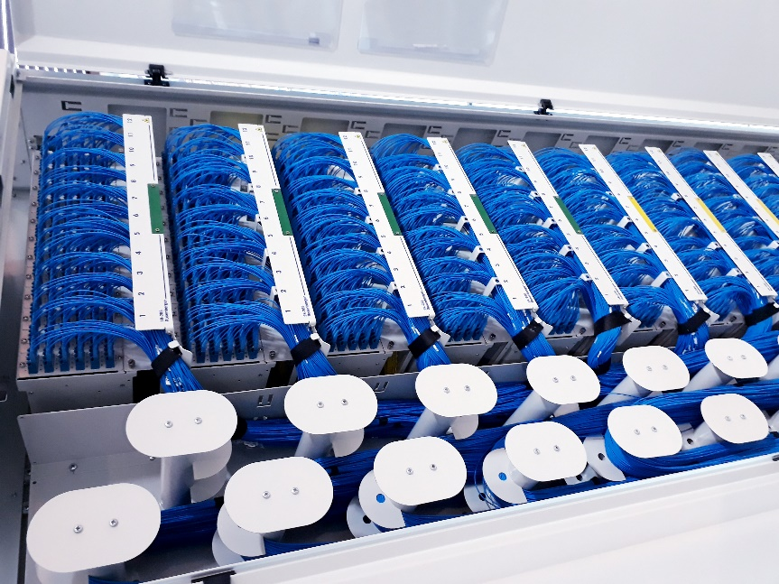
Currently installed with South American customers, the ‘FTH-9 Plus Wave’ ODF cabinet has capacity for 1440 pairs / 2880 fiber count and up to 10 SR-9 PLUS Sub-racks with only a slim 300mm deep profile. Optical fiber installation is made easy with cable slack management included in the design, allowing for a single length optical patch cord to be used at 5.5m or 8m if two cabinets are installed back-to-back.

Maintenance is optimized with a unique horizontal fiber management system allowing for access without disturbing live optical cables. The FTH-9 is delivered with optimized entry ports for optical fiber ducting and has removable, lockable doors for easier installation and maintenance, with various color options available.

Rosenberger will display the FTH-9 cabinet with all its capabilities in Booth 947 at BICSI Fall, Las Vegas from September 30th to October 2nd.

About Rosenberger

Rosenberger is a privately-owned diversified Bavarian manufacturing company with sales of €1,300mio and over 11,000 employees globally. Rosenberger is a development and production leader in RF, Fiber Optic and Interconnect solutions, operating in the Data Center, Mobile Communication, Test + Measurement, Automotive, Medical, Industrial, Telematics and custom machining markets. Rosenberger Fiber Optics employs over 600 people and terminates over 4mio connectors per annum. Since 1991 Rosenberger is an expert in innovative fiber optic cabling infrastructure and service solutions for Data Centers, Local Networks, Telecom and Industrial markets.

Rosenberger North America is headquartered at 309 Colonial Drive, Akron, PA 17501 Telephone: +1 717 859 8900
www.rosenberger.com and is a wholly owned subsidiary of Rosenberger Hochfrequenztechnik GmbH & Co. KG, P.O. Box 1260, D-84526, Tittmoning Telephone: +49-8684-18-0 www.rosenberger.de

